Synthesis

Why rst_ni net fanout appeared in the max_fanout violations list and clk_i didn’t?

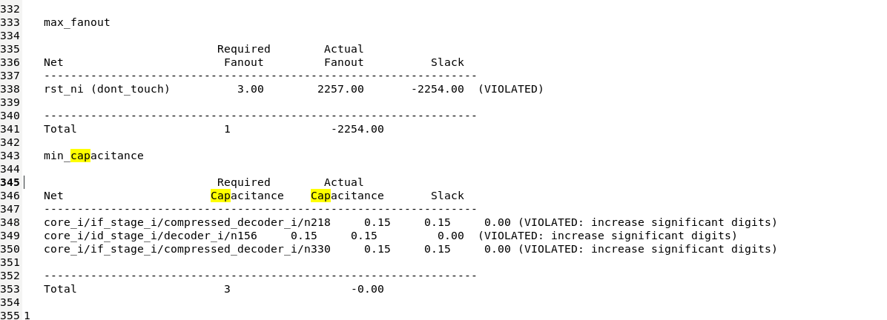

DFT-FM

Sleep_unit_i Failed point

During DFT formal verification, we encountered a mismatch on a net related to scan_cg_en_i and test_mode. The implementation had test_mode set to '0' (functional mode), while in the RTL, scan_cg_en_i was set to '1', leading to a comparison failure. However, since this signal was inserted in the original RTL solely for DFT purposes, can it be safely ignored in the equivalence check?

